Snowflake CSV Data Loading and Analysis
End-to-End Practical: Object Creation, Ingestion, Validation, Analysis, and Cleanup - Aryan Prakash

Objective

To perform a hands-on Snowflake practical covering the full workflow of loading and analyzing CSV data: dataset inspection, object creation, data ingestion, validation, basic analysis, object verification, and resource cleanup. All objects for this task are suffixed with _ARYAN to identify them as part of this exercise.

Step 1: Dataset Analysis

The source file retail_sales.csv was inspected before loading it into Snowflake, to confirm its column names, data types, and record count.
- ORDER_ID — Integer — Unique order identifier
- PRODUCT — Text — Product name
- QUANTITY — Integer — Units sold
- UNIT_PRICE — Decimal — Price per unit
- CITY — Text — Customer location
Record count: 12 data rows (13 lines including the header), confirmed with wc -l on the source file.

Step 2: Environment Setup

A dedicated database, schema, and virtual warehouse were created for this exercise, each suffixed with _ARYAN.

CREATE DATABASE IF NOT EXISTS RETAIL_DB_ARYAN;
CREATE SCHEMA IF NOT EXISTS RETAIL_DB_ARYAN.RAW_ARYAN;
USE SCHEMA RETAIL_DB_ARYAN.RAW_ARYAN;
CREATE WAREHOUSE IF NOT EXISTS RETAIL_WH_ARYAN
WAREHOUSE_SIZE = 'XSMALL'
AUTO_SUSPEND = 60
AUTO_RESUME = TRUE
INITIALLY_SUSPENDED = TRUE;
USE WAREHOUSE RETAIL_WH_ARYAN;
SELECT CURRENT_DATABASE(), CURRENT_SCHEMA(), CURRENT_WAREHOUSE();

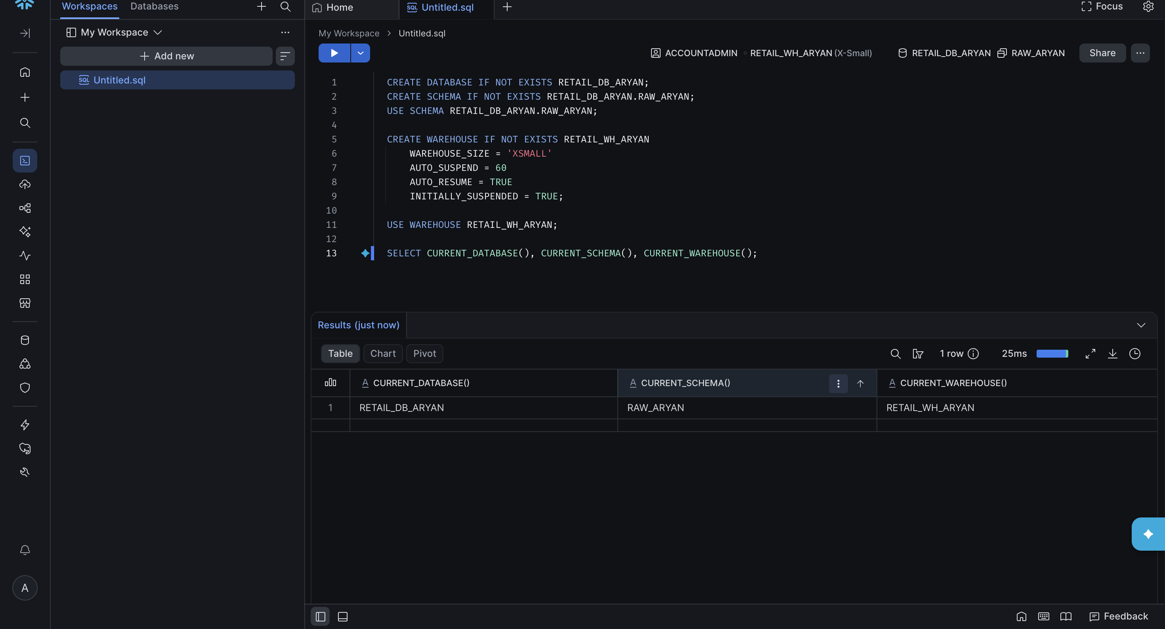

Step 3: Target Table Creation

The SALES_ARYAN table was created with one column per field in the source CSV, then verified with DESCRIBE TABLE.

CREATE TABLE IF NOT EXISTS SALES_ARYAN (
ORDER_ID NUMBER(10, 0),
PRODUCT VARCHAR(100),
QUANTITY NUMBER(10, 0),
UNIT_PRICE NUMBER(12, 2),
CITY VARCHAR(100)
);

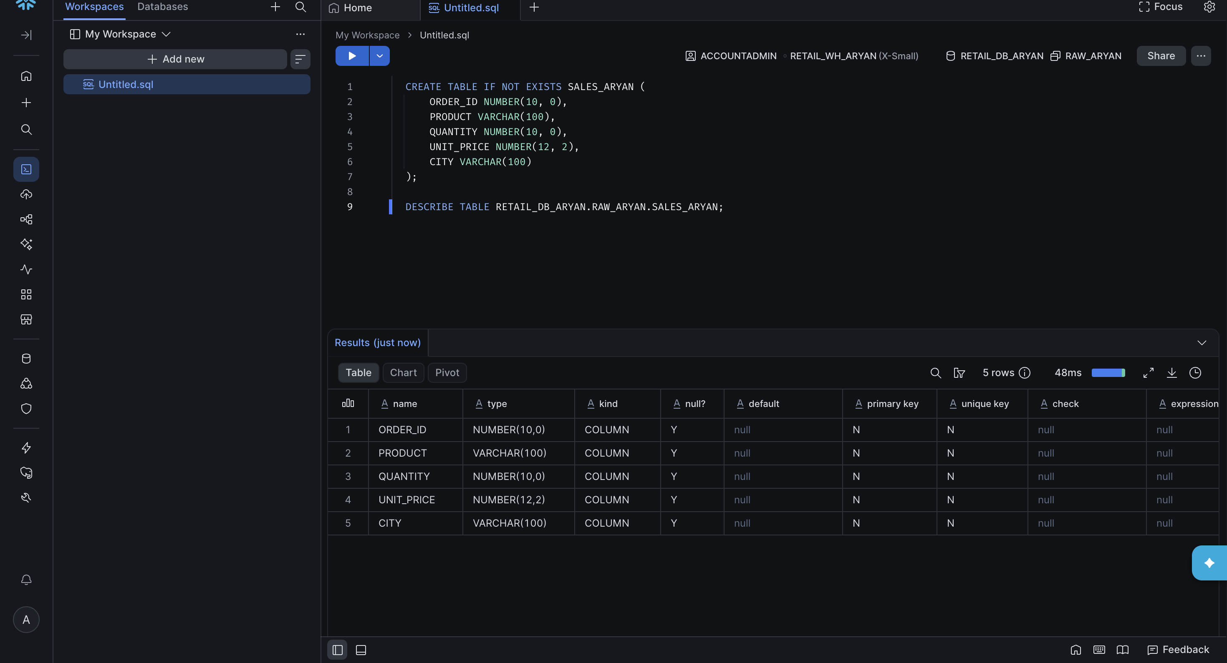

Step 4: File Format and Stage Configuration

A CSV file format and an internal stage were created to prepare for loading the data.

CREATE FILE FORMAT IF NOT EXISTS RETAIL_CSV_FORMAT_ARYAN
TYPE = CSV
SKIP_HEADER = 1
FIELD_OPTIONALLY_ENCLOSED_BY = '"'
EMPTY_FIELD_AS_NULL = TRUE;
CREATE STAGE IF NOT EXISTS RETAIL_STAGE_ARYAN
FILE_FORMAT = 'RETAIL_CSV_FORMAT_ARYAN';

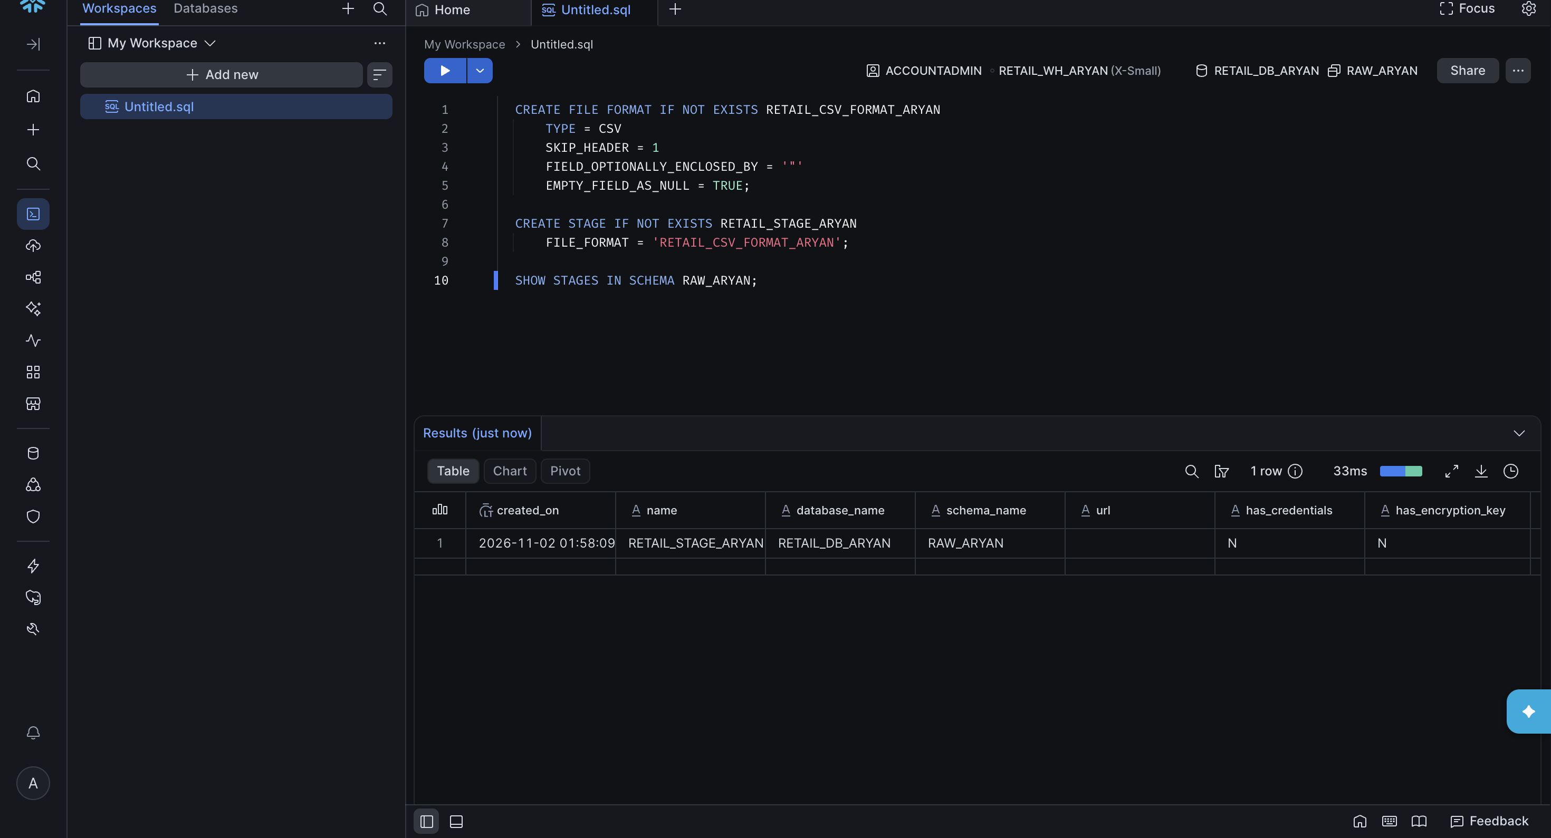

Step 5: CSV Upload and Data Loading

The retail_sales.csv file was uploaded to RETAIL_STAGE_ARYAN and loaded into SALES_ARYAN using Snowsight's Load Data wizard, which runs the equivalent of a COPY INTO behind the scenes.

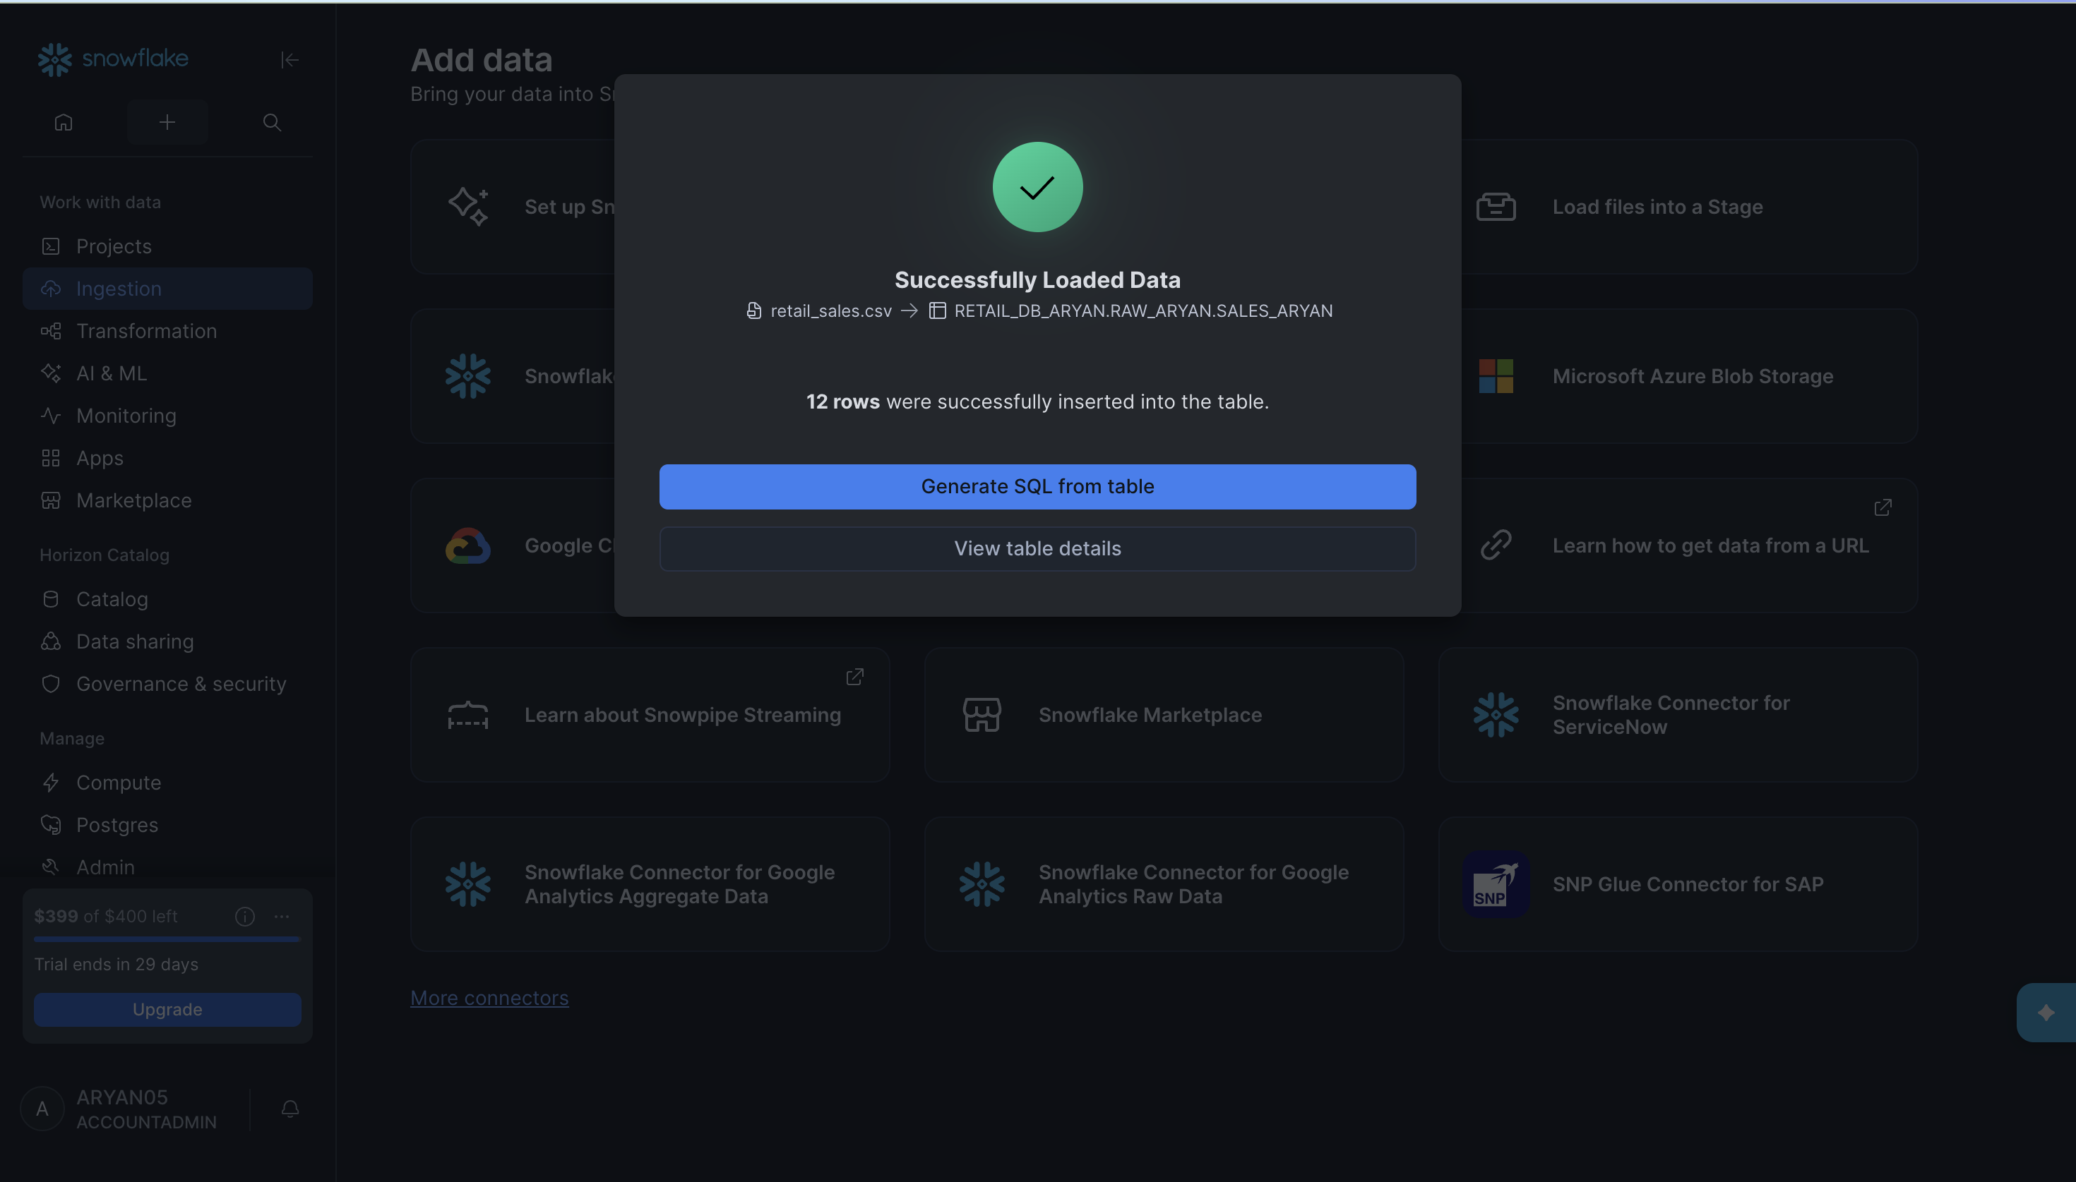

Step 6: Verification of Loaded Records

SELECT COUNT(*) AS TOTAL_RECORDS
FROM RETAIL_DB_ARYAN.RAW_ARYAN.SALES_ARYAN;

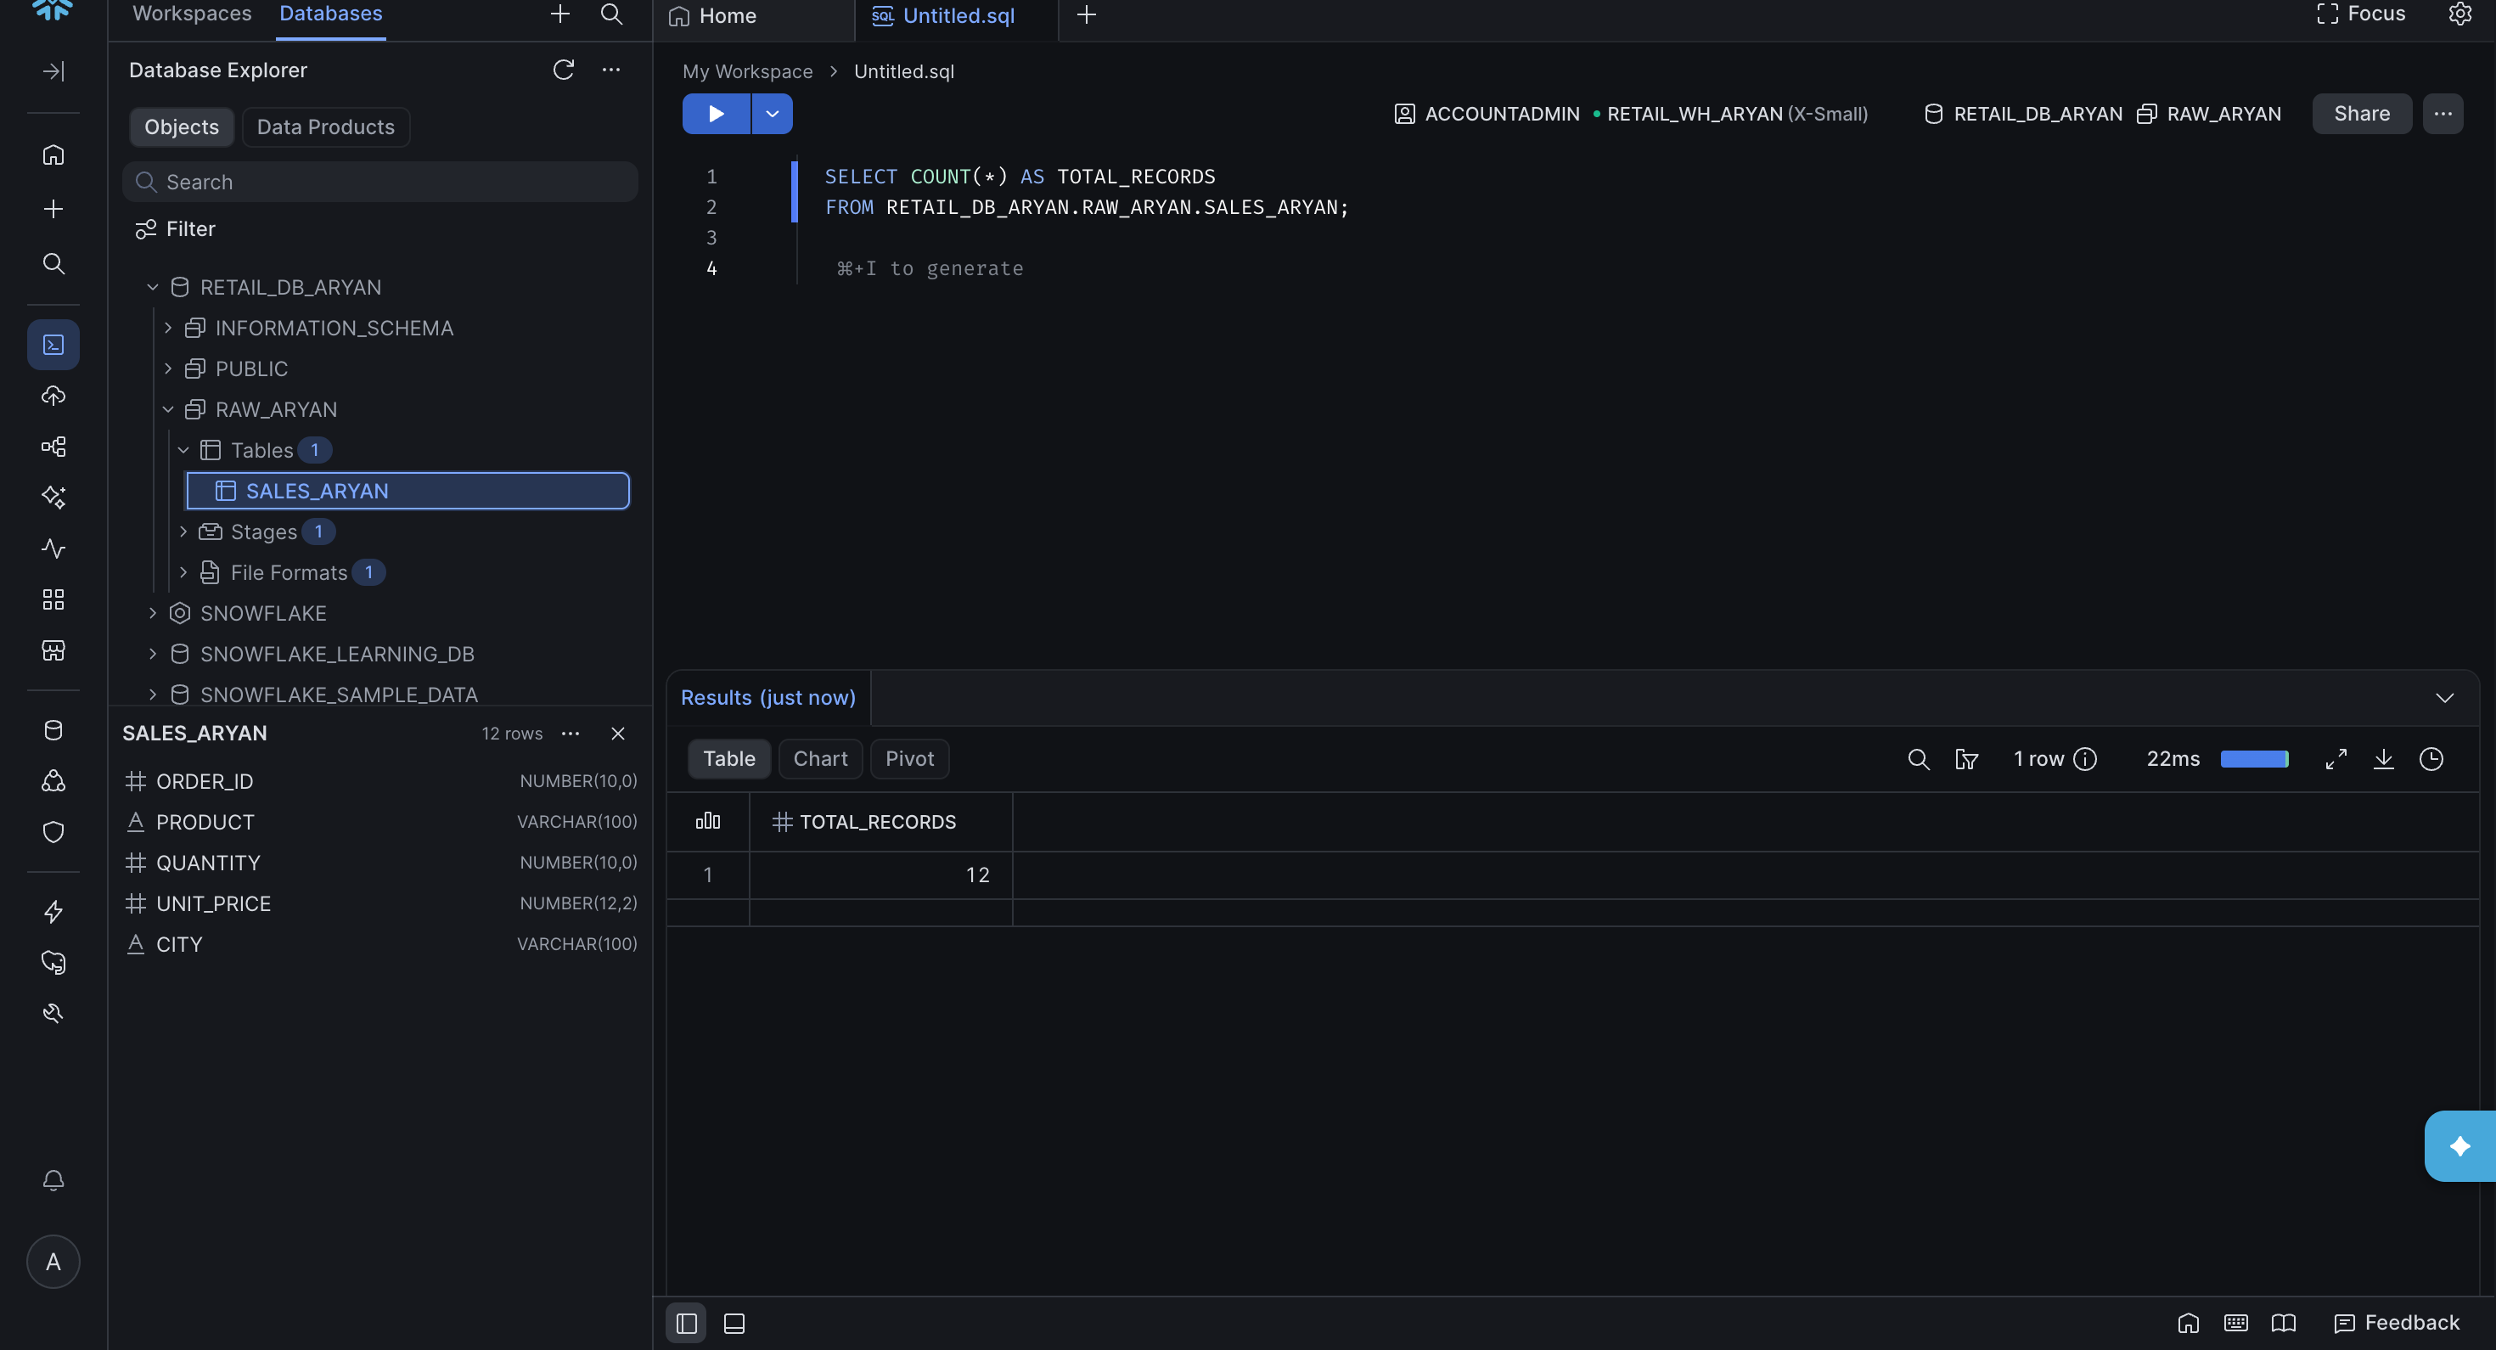

SELECT * FROM RETAIL_DB_ARYAN.RAW_ARYAN.SALES_ARYAN
ORDER BY ORDER_ID;

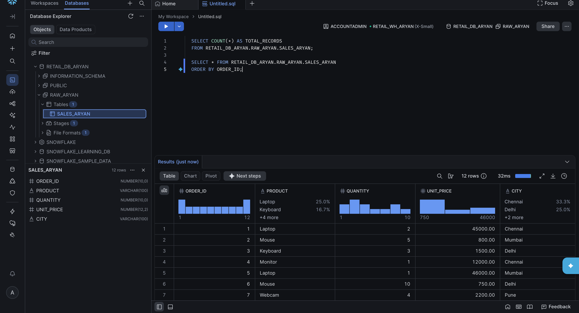

Step 7: Basic Data Analysis

With the data loaded, filtering, sorting, aggregation, NULL checks, and duplicate checks were performed to explore and validate the dataset.

7.1 Filtering

SELECT * FROM RETAIL_DB_ARYAN.RAW_ARYAN.SALES_ARYAN
WHERE CITY = 'Chennai';

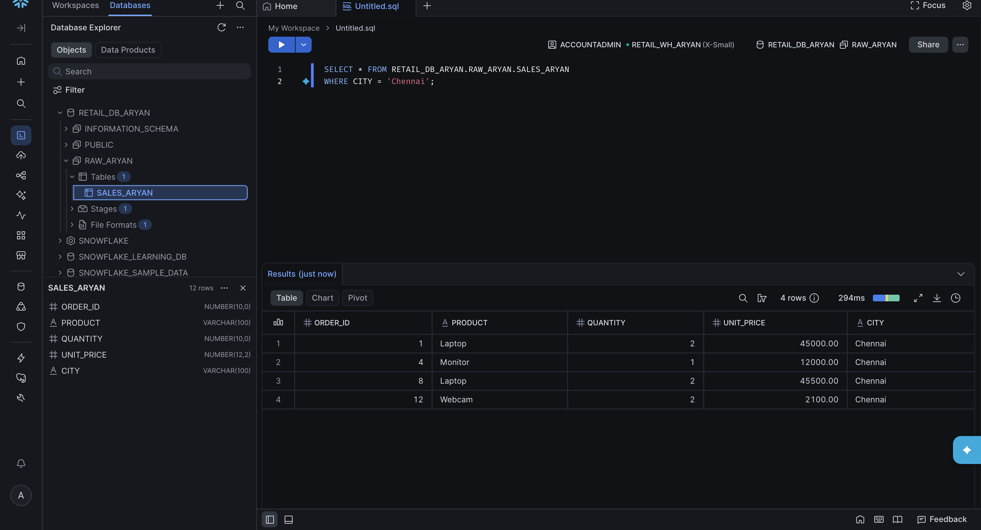

7.2 Sorting

SELECT PRODUCT, UNIT_PRICE FROM RETAIL_DB_ARYAN.RAW_ARYAN.SALES_ARYAN
ORDER BY UNIT_PRICE DESC;

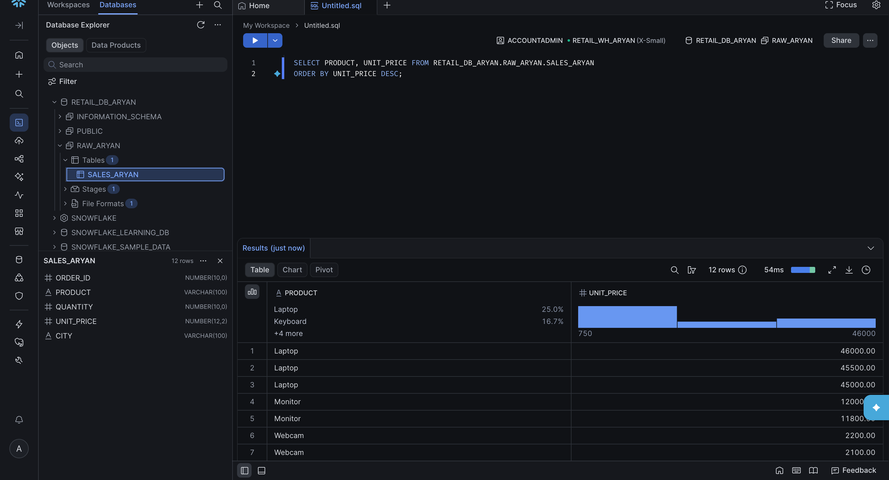

7.3 Aggregation

SELECT CITY, SUM(QUANTITY * UNIT_PRICE) AS TOTAL_REVENUE
FROM RETAIL_DB_ARYAN.RAW_ARYAN.SALES_ARYAN
GROUP BY CITY
ORDER BY TOTAL_REVENUE DESC;

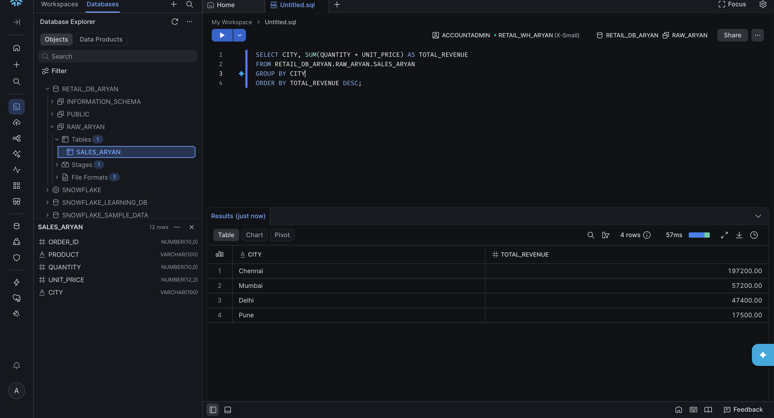

7.4 NULL Checks

SELECT
SUM(CASE WHEN ORDER_ID IS NULL THEN 1 ELSE 0 END) AS NULL_ORDER_ID,
SUM(CASE WHEN PRODUCT IS NULL THEN 1 ELSE 0 END) AS NULL_PRODUCT,
SUM(CASE WHEN QUANTITY IS NULL THEN 1 ELSE 0 END) AS NULL_QUANTITY,
SUM(CASE WHEN UNIT_PRICE IS NULL THEN 1 ELSE 0 END) AS NULL_UNIT_PRICE,
SUM(CASE WHEN CITY IS NULL THEN 1 ELSE 0 END) AS NULL_CITY
FROM RETAIL_DB_ARYAN.RAW_ARYAN.SALES_ARYAN;

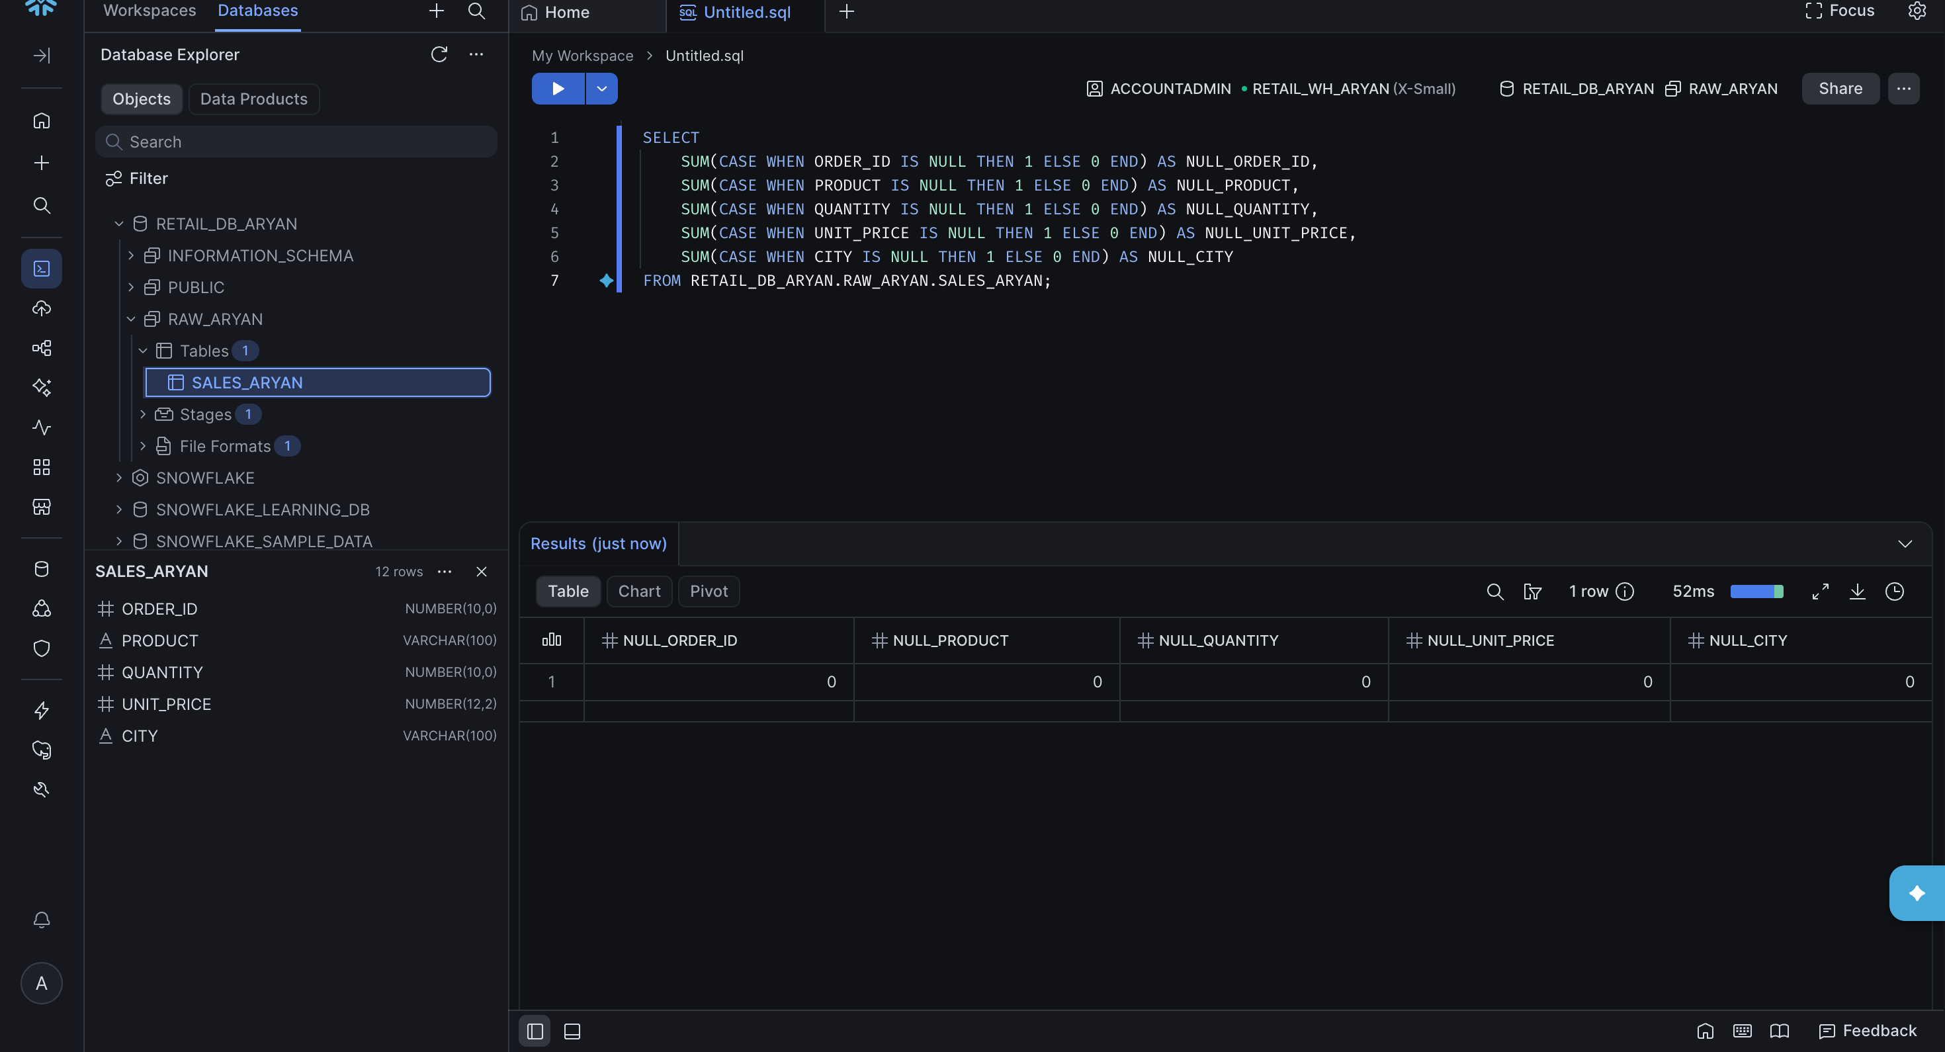

7.5 Duplicate Check

SELECT ORDER_ID, COUNT(*) AS OCCURRENCES
FROM RETAIL_DB_ARYAN.RAW_ARYAN.SALES_ARYAN
GROUP BY ORDER_ID
HAVING COUNT(*) > 1;

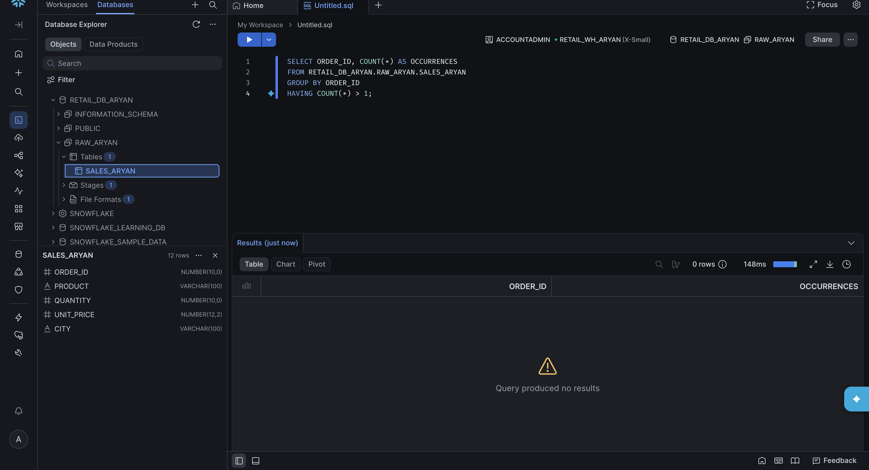

Step 8: Verification of Created Objects

Each object created during this exercise was confirmed using SHOW commands before proceeding to cleanup.

SHOW DATABASES LIKE 'RETAIL_DB_ARYAN';
SHOW SCHEMAS IN DATABASE RETAIL_DB_ARYAN;
SHOW WAREHOUSES LIKE 'RETAIL_WH_ARYAN';
SHOW TABLES LIKE 'SALES_ARYAN' IN SCHEMA RETAIL_DB_ARYAN.RAW_ARYAN;
SHOW FILE FORMATS IN SCHEMA RETAIL_DB_ARYAN.RAW_ARYAN;
SHOW STAGES IN SCHEMA RETAIL_DB_ARYAN.RAW_ARYAN;



